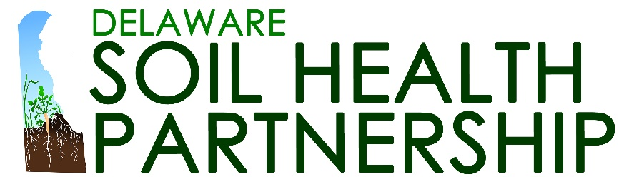

Submit Content

  - To submit content for the DE SHP site, email this form to: jen.nelson@resourcesmartllc.com
Attach with the email an image or your organization’s logo- ideal image size for a photo is 1200 x 628 px.
If you’re sending a logo as your featured image, keep in mind that the image preview shown on the main resource page will focus on the center of the image. Wide logos may be cut off at the sides, so square or round logos are preferred.

Title:

Introductory text:
(Can be the first paragraph of your article, executive summary or description.)

Organization:

Author:

Link to Content:

Geography: | ___ Delaware  ___ Delmarva  ___ Northeast Region  Other:
Management Practice: | ___ Cover Crops  ___ No-Till  Other:
Research Focus: | ___ Disease Management  ___ Nutrient Management  ___ Pest Management  ___ Weed Management  Other:
Resource Type: | ___ Article or Blog Post  ___ Decision Tool  ___ Partnership from the Region  ___ Recorded Event  Other:
Tags: | ___ Economics  ___ Farmers  ___ Mixed Species  ___ Planting Dates  ___ Planting Green  ___ Seeding Rates  ___ Soil Biology  ___ Species Selection  ___ Termination  ___ Vegetables  Other:

